building more resilient sanitation systems and improving reslience assessment tools

INTRODUCTION AND BACKGROUND
Climate change is the defining challenge of the 21st Century. As noted by the IPCC 6th Assessment Report, the effects of climate change are already being felt as average temperatures rise and more frequent and severe extreme events, including heat waves, wildfires and flooding, as well as slower onset threats from groundwater flooding and drought (IPCC, 2021).
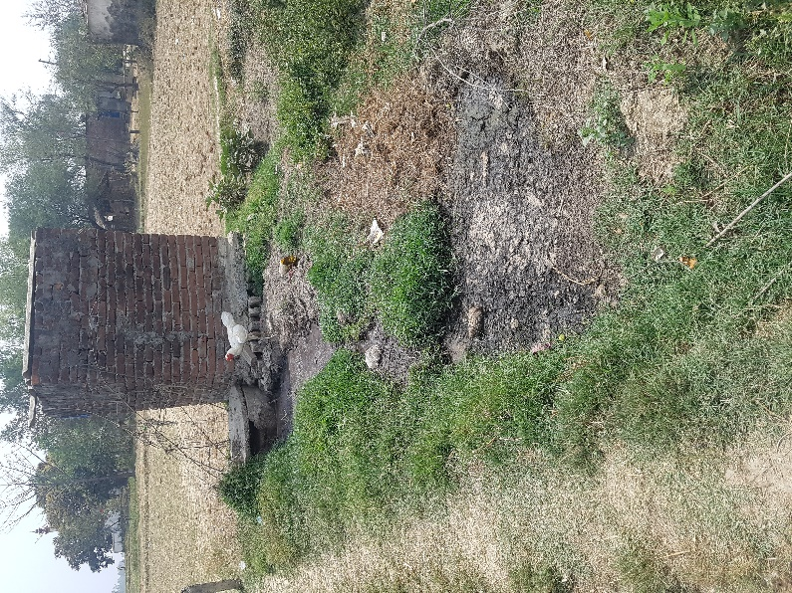
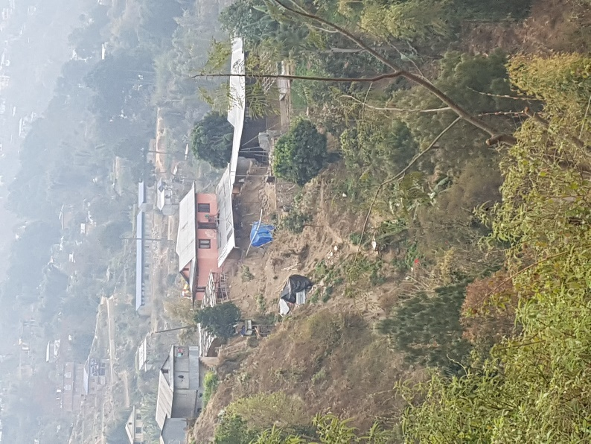
Changes in climate impacts on the delivery of basic services such as sanitation (Howard et al. 2016). These impacts may be direct: damage to toilets or making them inaccessible; flooding of pits; insufficient water to flush water-based sanitation including septic tanks and pour-flush latrines. They may also be indirect: damage to roads and bridges that prevent access for tankers to empty tanks and pits; damage to power supplies that may prevent effective functioning of faecal sludge treatment plants (Figure 1).
Figure 1 Left: Rainfall caused mudslides in Nepal Right: Faecal sludge from pit discharging into open field (Image credit: Anjali Manandhar Sherpa)

Both direct and indirect impacts of climate change may lead to the temporary or permanent loss of access to sanitation facilities and force people to revert to open defecation. Climate events, both rapid and slow onset, may lead to damage or widespread environmental contamination. Direct and indirect impacts will result in a significant increase in the risk of infectious disease.
Sustainable Development Goal 6 includes a commitment to universal access to sanitation. The majority of people who do not have access live in low- and middle-income countries in Africa, Asia and Oceania. On-site sanitation is increasingly the preferred option for providing sanitation as it is lower cost but within urban areas on-site systems require periodic emptying.

THE NEED TO BUILD RESILIENCE IN SANITATION
Sanitation is vulnerable to the effects of climate change and so strengthening resilience is critical. Resilience is the ability of the systems to cope with, respond to, and build back from, climate shocks and stress. It is complementary but the not the same as sustainability of services. Climate resilience is the ability of sanitation systems to cope with unexpected events (whether in terms of timing, frequency or magnitude) whereas sustainability is about the ability of systems to continue functioning under a known set of conditions.

HOW RESILIENCE CAN BE STRENGTHENED
‘Infrastructure that is designed and built to withstand climate hazards is important to build resilience of sanitation but it is unlikely to be sufficient on its own. Resilience requires adaptive management, that allows adjustments in practice and action in response to events learns from events and emerging evidence to plan for future events. A critical step to build resilience will be to ensure that sanitation managers and operators follow best practice. This will form the basis of developing more responsive adaptive management procedures in the future.
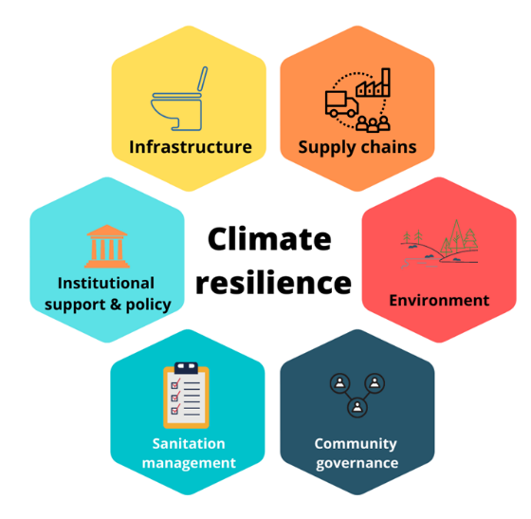
In addition to infrastructure and management, it is important to consider the environmental setting within which sanitation systems are located as these may affect the impact of climate events. Improvements in environmental management may be required in order to protect sanitation systems. Maintaining supply chains during and after climate events is important, such as community access to pit emptying or hardware to rebuild toilets. Bottlenecks may be found in supply chains – for instance bridges over rivers that experience flash flooding - that increase vulnerability of sanitation because they may prevent access to communities for sanitation services or materials needed to maintain or rebuild toilets.
Figure 2 Conceptual framework to assess climate resilience of sanitation
The support to the providers of on-site sanitation (households, builders, emptying services) from government is important in promoting and building resilience. This support may be regulatory or advisory, or a combination of both. It is also important that there is accountability for the provision and operation of sanitation services, and their regulation, and that citizens have the ability to hold government, service providers and their community to account for their actions.
Climate impacts on sanitation are not experienced equally within populations or even within households, and people have unequal power and access to resources for responding to impacts. Resilience can be strengthened by assessing how different segments of society experience climate impacts on sanitation and developing solutions that are tailored to the diverse needs of vulnerable groups.

UNDERSTANDING RESILIENCE IS A KEY FIRST STEP
In order to build more resilient systems, it is important to be able to reliably assess how resilient current systems are and what needs to be improved or changed to strengthen resilience. Assessment needs to address a range of factors that affect resilience. This therefore requires data on: environments; infrastructure; management; governance and accountability; supply chains; institutional support; and the policy environment (Figure 2).
A wide range of data needs to be collected and then transformed into metrics that allow judgements to be made regarding the degree of resilience that exists. Such metrics should support identifying where further actions, assistance and investment are required to strengthen resilience; and to inform the prioritisation of communities or interventions where actions are more urgently required.
Assessments of resilience need to be rooted in an understanding of the types and nature of threats that arise from climate change in particular locations and settings. This does not mean that there must be detailed local climate projections developed for each location and community but does require an understanding of the likely consequences of climate change in terms of particular types of events. Figure 3 and Table 1 below summarise some of the key climate-related hazards that may need to be considered.
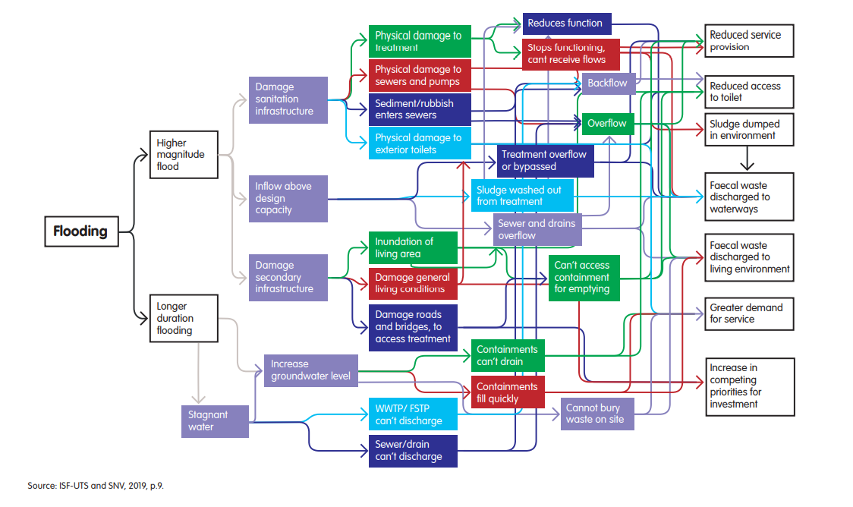
Figure 3 Threats from flooding to urban sanitation systems (from ISF-UTS and SNV, 2019)
Climate change effect | Potential hazards and changes | Examples of risks for on-site sanitation systems
More intense or prolonged precipitation | - Increased flooding  - Increased erosion, landslides  - Contamination of and damage to surface water and groundwater supplies  - Changes to groundwater recharge and groundwater levels | - Destruction and damage to sanitation infrastructure  - Damage to other infrastructure/systems on which sanitation systems rely  - Flooding of on-site systems causing spillage and contamination  - Flooding and collapse of pit latrines, including via groundwater  - Overflow and/or obstruction of septic systems  - Floating of septic systems due to groundwater levels
More variable or declining rainfall or runoff | - Longer dry seasons/periods  - Droughts (both seasonal and longer-term)  - Reduced surface water flows  - Reduced groundwater levels/resources | - Declining water supply impeding function of water-reliant sanitation systems  - Obstruction creating reduced capacity in rivers or ponds that receive wastewater
Sea-level rise | - Saline intrusion in coastal/low-lying zones  - Rising groundwater levels in coastal/low-lying zones  - Higher risk of inundation, especially from extreme weather events  (potentially contributing to flooding, erosion, landslides) | - See impacts from flooding above  - Damage to underground infrastructure from rising groundwater levels  - Reduced effectiveness of biological treatment processes due to saltwater exposure from saline intrusion into wastewater influent
More variable or increasing  temperatures | - Higher ambient air temperatures in homes or  facilities  - Higher freshwater temperatures  - Hot and cold temperature extremes | - Reduced efficiency of biological wastewater treatments (if temperature exceeds or falls below operational limits)  - Proliferation of algal blooms or microbes carried by vectors in water  - Increased corrosion of sewers
More frequent or intense storms or cyclones | - Increased flooding  - More extreme winds | - See impacts from flooding above  - Damage to latrine superstructures and other infrastructure  - Damage to other infrastructure/systems on which sanitation systems rely (e.g. electricity networks for pumping; road networks used by FSM vehicles)
Table 1: Climate hazards of importance to sanitation (modified from Kohlitz et al. 2019)

DEVELOPING RESILIENCE ASSESSMENT APPROACHES
Mechanisms to assess resilience to climate change have been developed for many different aspects of society, ranging from health systems to key infrastructure. In high income countries there are a number of initiatives to support more resilient services and metrics for assessing resilience for large (e.g. ARCADIS) and small (e.g. Nokes, 2012) systems.
There have been fewer studies that have assessed the resilience of water and sanitation systems in low- and middle-income countries (LMICs). However, methods to assess resilience have been developed including simplified metrics developed by the How Tough is WASH project (Howard et al 2021), the monitoring tools developed by GWP and UNICEF (GWP & UNICEF, 2017) and a framework of principles and policy and programming responses (ISF-UTS and SNV, 2019). There is a need to develop more empirical evidence on the use of resilience assessment approaches and metrics in LMICs to provide stronger evidence on the priorities for strengthening resilience.

THE SCARE PROJECT
The Sanitation and Climate: Assessing Resilience and Emmissions (SCARE) project is investigating the resilience of sanitation systems in three countries: Nepal, Ethiopia and Uganda. The objective of the project in relation to resilience is enhance the resilience of sanitation services to climate change in resource-limited settings and to identify the most appropriate climate products and services that support decision-making. To assess resilience, existing metrics and approaches will be used and refinements made based on field experiences.
The project is funded by the Bill & Melinda Gates Foundation and will run for 3 years (2020-2023). The project is led by the University of Bristol (UK), with the partners being: Kathmandu University (Nepal), Haramaya University (Ethiopia), Kyambogo University (Uganda), University of Leeds (UK), University of Technology Sydney (Australia) and the Global Green Growth Institute.

THE SCARE METHODOLOGY
The methods used by SCARE to assess resilience are drawn from those from the How tough is WASH metric and the GWP/UNICEF monitoring tool. In addition, methods applied in assessing resilience to climate change for other sectors have also been reviewed. Ethical approval for the field studies will be obtained from the University of Bristol and within each country, following national ethical approval requirements and guidance.
The project is collecting data across six key domains as shown in Figure 2. We have selected 14-30 communities from Nepal, Uganda, and Ethiopia to reflect the identified climatic and ecological zones in each country. Sites are distributed between lowlands, midland and highlands in Oromia and reflect the three key ecological zones in the country. The communities selected in each country provide a range of communities that are broadly indicative of the types of communities.

DATA COLLECTION METHODS
A total of 50 attributes of resilience will be assessed across the six domains. Data will be collected through a mix of methods: geospatial analysis; site and risk inspection methods; community surveys; focus group discussion and key informant interviews; and document reviews. For geospatial analysis we will use images from publicly available platforms, such as Google EarthTM; site and risk inspections will use standardised tools such as sanitary inspections based on those available from WHO but modified to better reflect resilience in each context following recommended practice. We will also develop standardised tools for assessing the sanitation service chain based on the extensive knowledge and experience of working on sanitation within the study team.
Community surveys will be carried out with a representative sample of households from the selected communities. We will use a stratified random sampling approach with the main stratifiers being community (to ensure that households from each community are included) and technology (covering different types of tanks and pit latrines). We will calculate the sample size required for each country using conservative assumptions. We have developed a questionnaire, which has been translated in local languages and back-translated, and tested in each country. Data will be analysed using a standardised approach across each country to ensure consistency. The data will feed into final metrics to provide a scoring of resilience in each community and to support analysis of trends and priorities in each country,
Focus groups and key informant interviews will be based on pre-defined topic guides that will be pre-tested with the key audience types and delivered in local languages, with translation of responses into English to support consistency in reporting. Finally, document reviews will critically appraise the content of national, local and organisational policy, planning and operational documents and guidance using standardised data extraction measures to support consistent data analysis.

EXPECTED OUTPUTS OF THE PROJECT
The SCARE project will provide the most comprehensive set of data on the resilience of on-site sanitation systems from LMICs collected to date. The insights from the project will provide robust evidence to support decision-makers in the three countries and elsewhere in identifying future needs for strengthening resilience.
The project will develop and define criteria that climate finance providers can use to better assess sanitation projects and that will support countries get better access to climate funds to invest in more resilient sanitation. We expect that this will unlock substantial new sources of funding for LMICs that provide development-adaptation co-benefits.
The project will also provide a refined set of assessment tools and metrics that can be used across LMICs to assess resilience of sanitation systems. This will provide sector experts, policy-makers and funders with mechanisms and guidance on how to undertake such assessments and to analyse and present data in ways that support prioritisation and decision-making and local, national and international levels. By improving and consolidating these tools, the project will help the sanitation sector make a step change in how it understands and acts to build resilience. We will develop a set of interactive manuals and other guidance that will support future users of these tools and support their ongoing refinement and development.

GET IN TOUCH
If you want to get more information about the SCARE project and to access the tools and guidance as these become available please visit our website: http://www.bristol.ac.uk/engineering/research/water-and-sanitation/sanitation-and-climate/ or email Dr Anisha Nijhawan (anisha.nijhawan@bristol.ac.uk).
References:
- ARCADIS. Measuring resilience in the water industry. https://www.unitedutilities.com/globalassets/z_corporate-site/about-us-pdfs/looking-to-the-future/measuring-resilience-in-the-water-industry_final.pdf (2017).
- GWP & UNICEF. WASH Climate Resilient Development Technical Brief: Monitoring and evaluation for climate resilient WASH. https://www.gwp.org/globalassets/global/about-gwp/publications/unicef-gwp/gwp_unicef_monitoring-andevaluation-brief.pdf (2017).
- Howard, G., Calow, R., Macdonald, A., & Bartram, J. (2016). Climate change and water and sanitation: likely impacts and emerging trends for action. Annual review of environment and resources, 41, 253-276.
- Howard, G., Nijhawan, A., Flint, A., Baidya, M., Pregnolato, M., Ghimire, A., ... & Wondim, T. (2021). The how tough is WASH framework for assessing the climate resilience of water and sanitation. npj Clean Water, 4(1), 1-10.
- IPCC, 2021: Climate Change 2021: The Physical Science Basis. Contribution of Working Group I to the Sixth Assessment Report of the Intergovernmental Panel on Climate Change [Masson-Delmotte, V., P. Zhai, A. Pirani, S.L. Connors, C. Péan, S. Berger, N. Caud, Y. Chen, L. Goldfarb, M.I. Gomis, M. Huang, K. Leitzell, E. Lonnoy, J.B.R. Matthews, T.K. Maycock, T. Waterfield, O. Yelekçi, R. Yu, and B. Zhou (eds.)]. Cambridge University Press. In Press.
- ISF-UTS and SNV, 2019. Considering climate change in urban sanitation: conceptual approaches and practical implications. The Hague: SNV.
- Kohlitz, J., Willetts, J., Gero, A., Lyons, S., Boisson, S., & Medlicott, K. (2019) Discussion Paper: Climate, Sanitation and Health. World Health Organization.
- Nokes, C. Water Supply Climate Change Vulnerability Assessment Tool Handbook Health Analysis & Information For Action (HAIFA). ESR Client Report No: CSC12010. (Environmental Science and Research Limited, Porirua, New Zealand, 2012).

